**LOVELY PROFESSIONAL UNIVERSITY**

**PUNJAB, INDIA**

**LET’S TRAVEL**

**(MAKE MY TRAVEL WEBSITE)**

**INTERNET PROGRAMMING LANGUAGE**

**CSE 326**

**SUBMITTED BY**

**DARSHAN K19RD A22 11912717**

**BALASUBRAMANIAN S NAIR K19RD A23 11912436**

**ALLAM CHANDRA SEKHAR REDDY K19RD A24 11910876**

Travel is the moving of objects or people between two geographical locations of relative distance. At times Introduction to travel can also include movements between different destinations with short stop overs on the way to the final destination to be reached. But in the modern era, the significance of travel has taken a center stage be it in terms of vacations and holidays or Business Travel and Cargo.

In the age of advanced technology, the travelling became so easy. With the help of websites, the travelling agencies reaching the customers easy, so that customers can get what they really wanted. Most of the websites are buildup with HTML, CSS, JS and many other programming languages. These websites provide facilities like flight, bus, train ticket booking and even hotels at discounted price.

Our moto is to created a fine and easy to use website with dynamic performance, by the end I think we succeeded somehow. I like to say that, “let’s travel” is our first website created using HTML, CSS and also little JavaScript. We took more than one month in creating this website. We wanted to submit a beautiful website, so we discussed about that clearly before starting our project. My groupmates gave me necessary and suitable suggestions so that collectively we end by with this website before the deadline.

Goals that we set:

* To create website before deadline.
* Easy to use website.
* To create website in a collaborative way among the group so that everyone can involve in the group.

|  |
| --- |
| Objectives   * To create websites using HTML, CSS. * Including quick navigation menu. * Containing Advertisement column. * To keep website simple and creative. * To use correct tags at correct places. * Easy to use.   Project outcome:   * We came to know so many new tags. * Proper positioning of content in the page. * We realized that if we stuck somewhere in the midst of the project, we have took the help of google but not give up the project, * Group co-operation is really important. * Finally, website creation is really fun.   Applications:  Travelling websites are like a menu in a restaurant. It helps to convey the facilities provides to customers. It is a very responsible task of a programmer to design website in such a manner that the customers should know what inside it properly.  A travelling website provides   * Hotel Booking * Flight ticket Booking * Bus ticket booking * Train ticket booking * To plan the trips * Cab booking * Offers   NOTE:  THIS PROJECT/ WEBSITE OPENS ONLY IN “FIREFOX” WEB BROWSER. SO, I AM KINDLY REQUESTING YOU THAT PLEASE OPEN IN “FIREFOX”. |
| Project Description.  In this project there are nearly five pages including introductory page.  First page will direct to home page when you click get started on the first introductory page. |

After this home page will open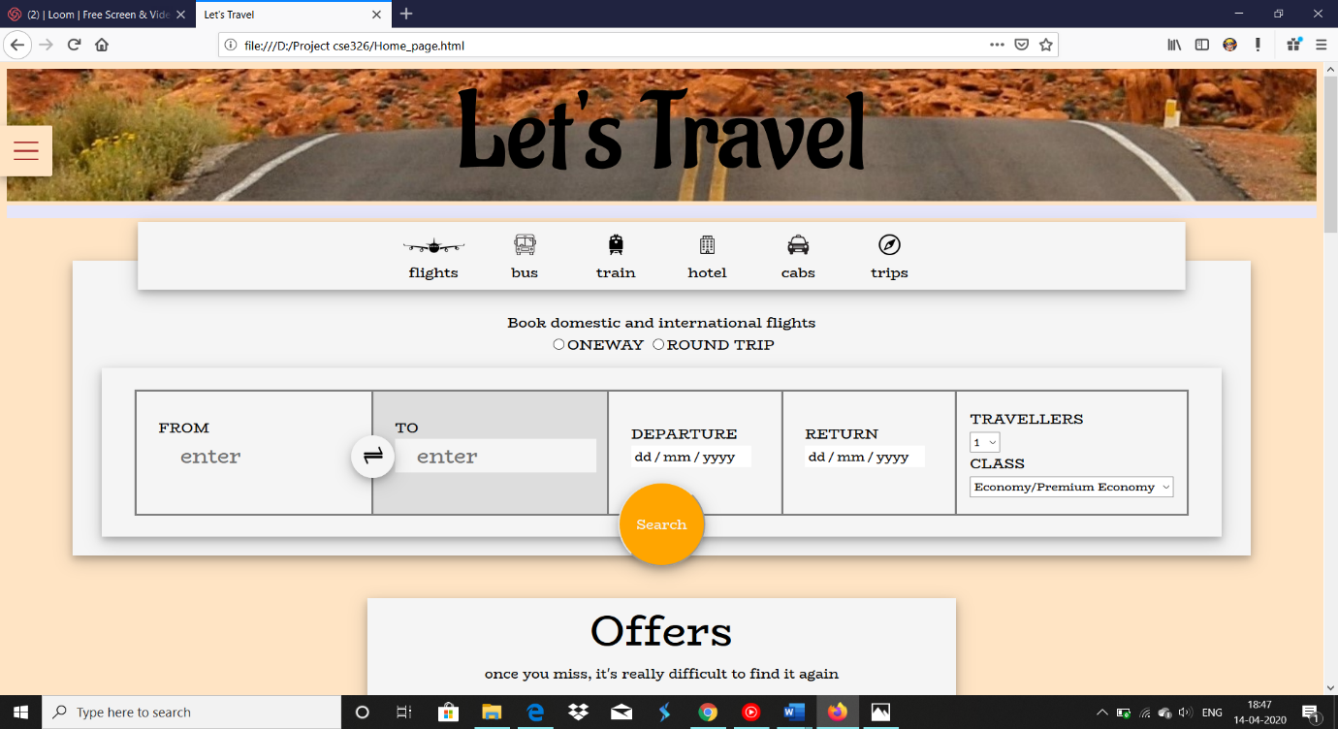

Indicates navigation menu which is fixed to the page

Indicates the mode of transport or hotel to book. You have to select

Which one you wanted to book.

Indicates that, you have to fill the necessary information.

Indicates the search button.

We used JavaScript in order to place the content when we click on flights or hotels or any other.

In the same entire page contains offers, trips, reviews and footer.

Offers:

In offers we used the keyframes so that it can change its slides in vertical direction.

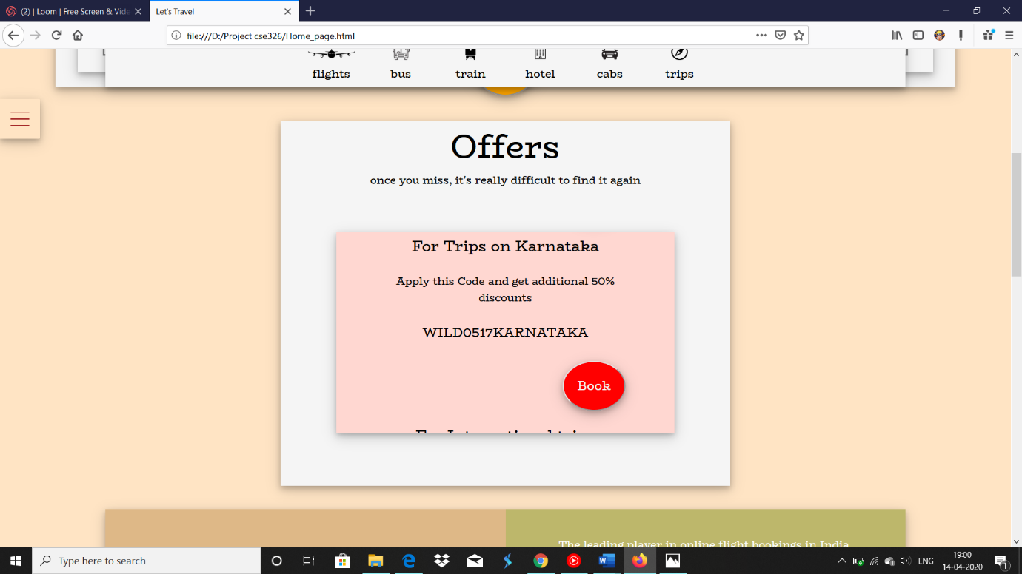

This contains ‘BOOK’ option to want to book.

Next, we have “why us?” column which is similar to about page.

We did not create an extra page in order to keep it simple.

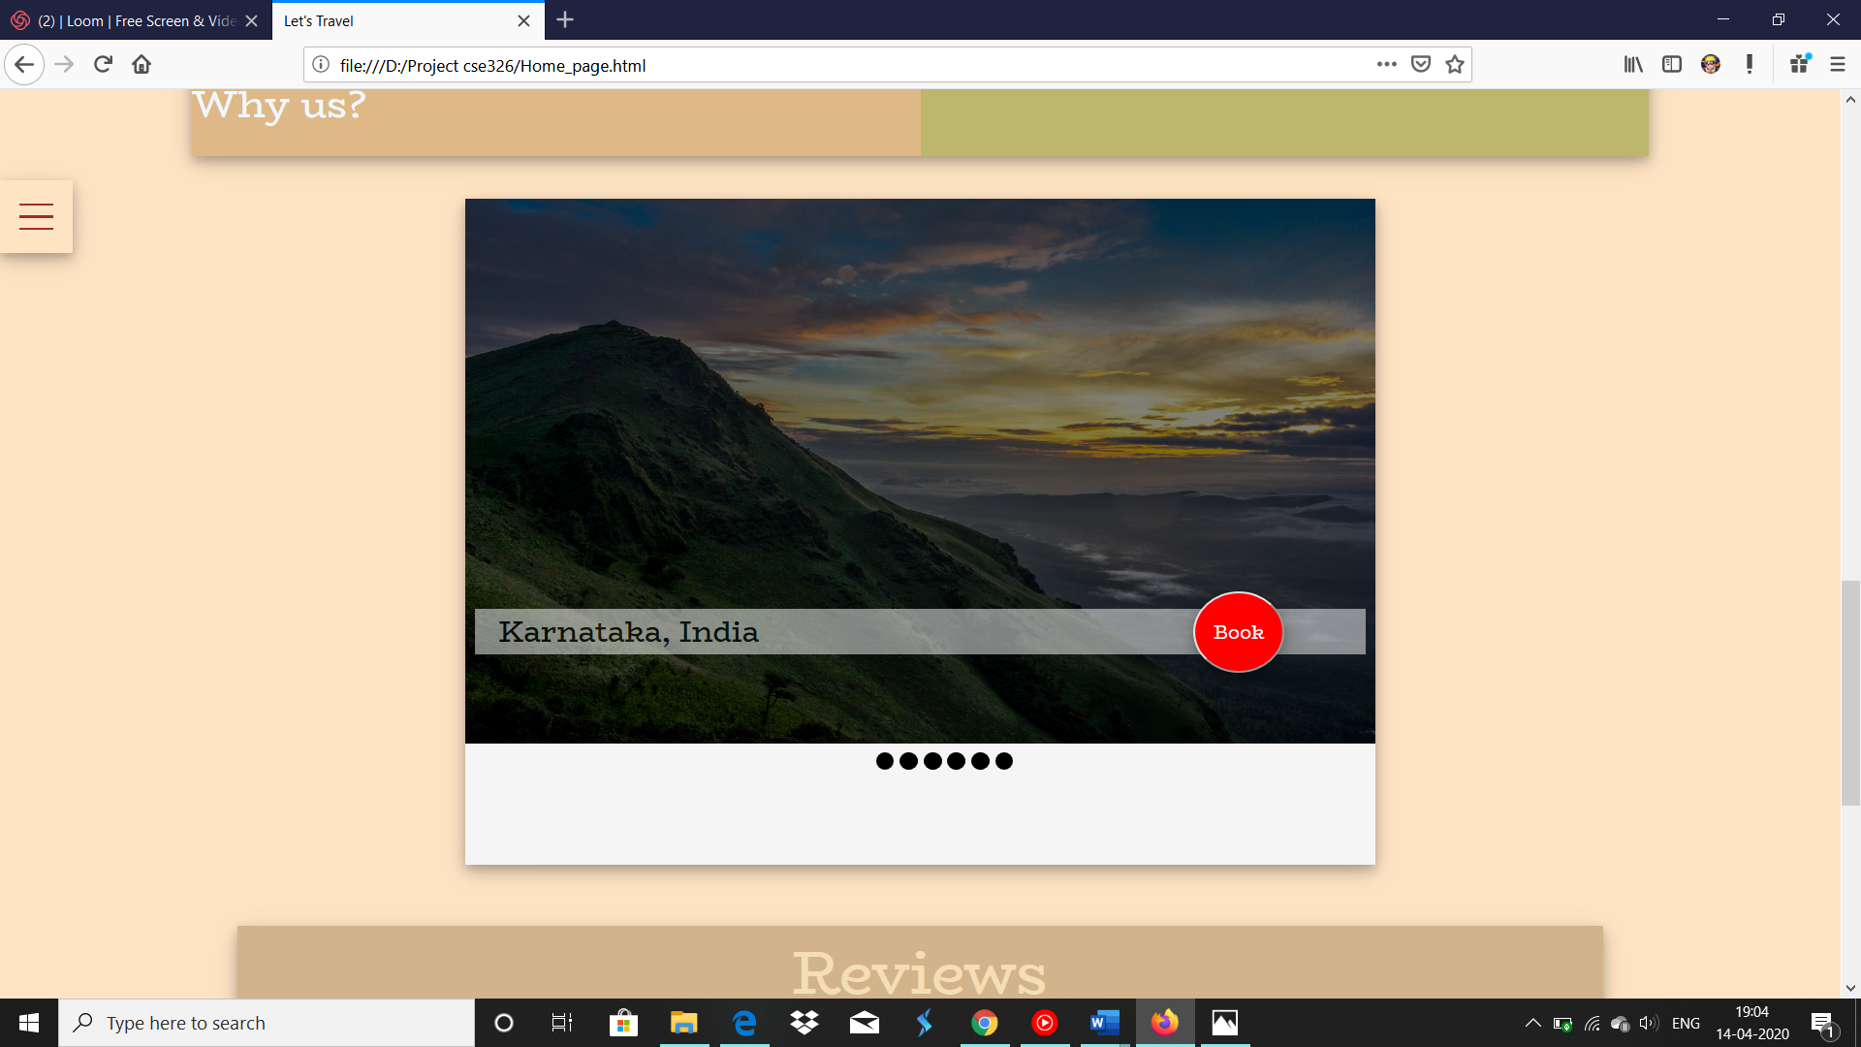

This also contain “BOOK” button so, that we can book from that slide only. Basically, it was a trip or a holiday planer.

Below the photo there are button so that we can change photos of different locations. It is a manual photo slider. We put it for trip section.

At the of the page we have reviews and footer.

Reviews section we put automat ic horizontal slider with the help of css.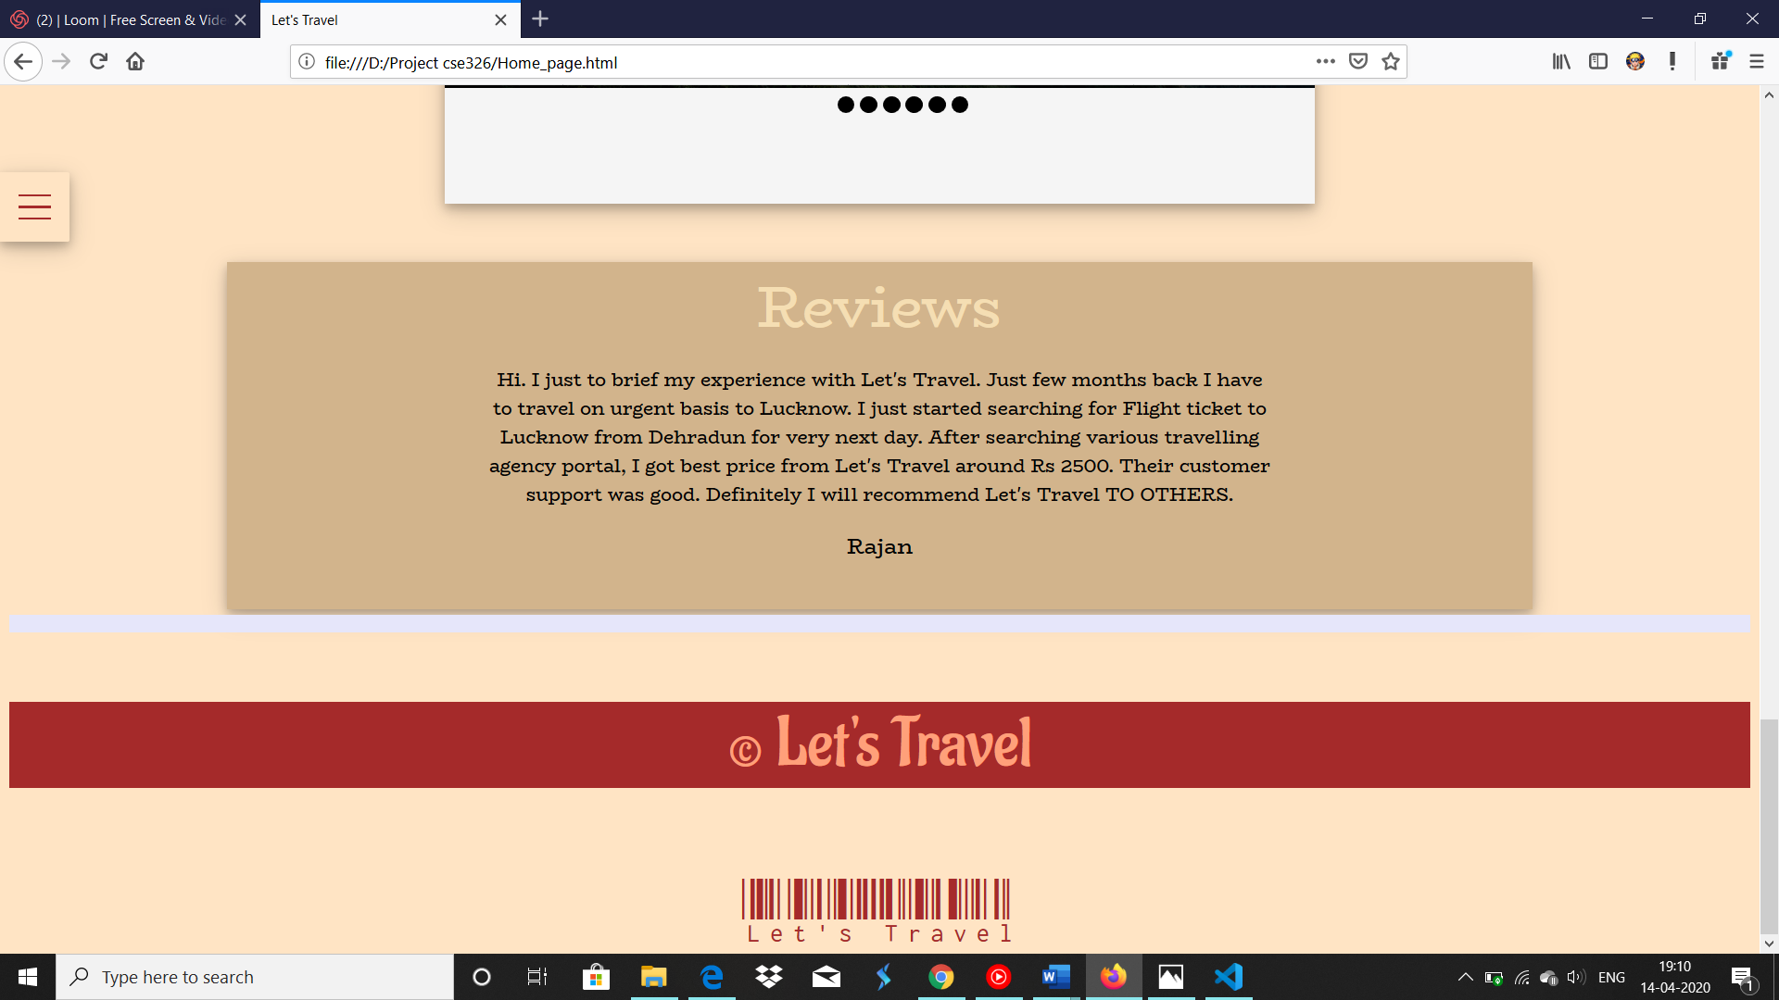

Navigation Menu

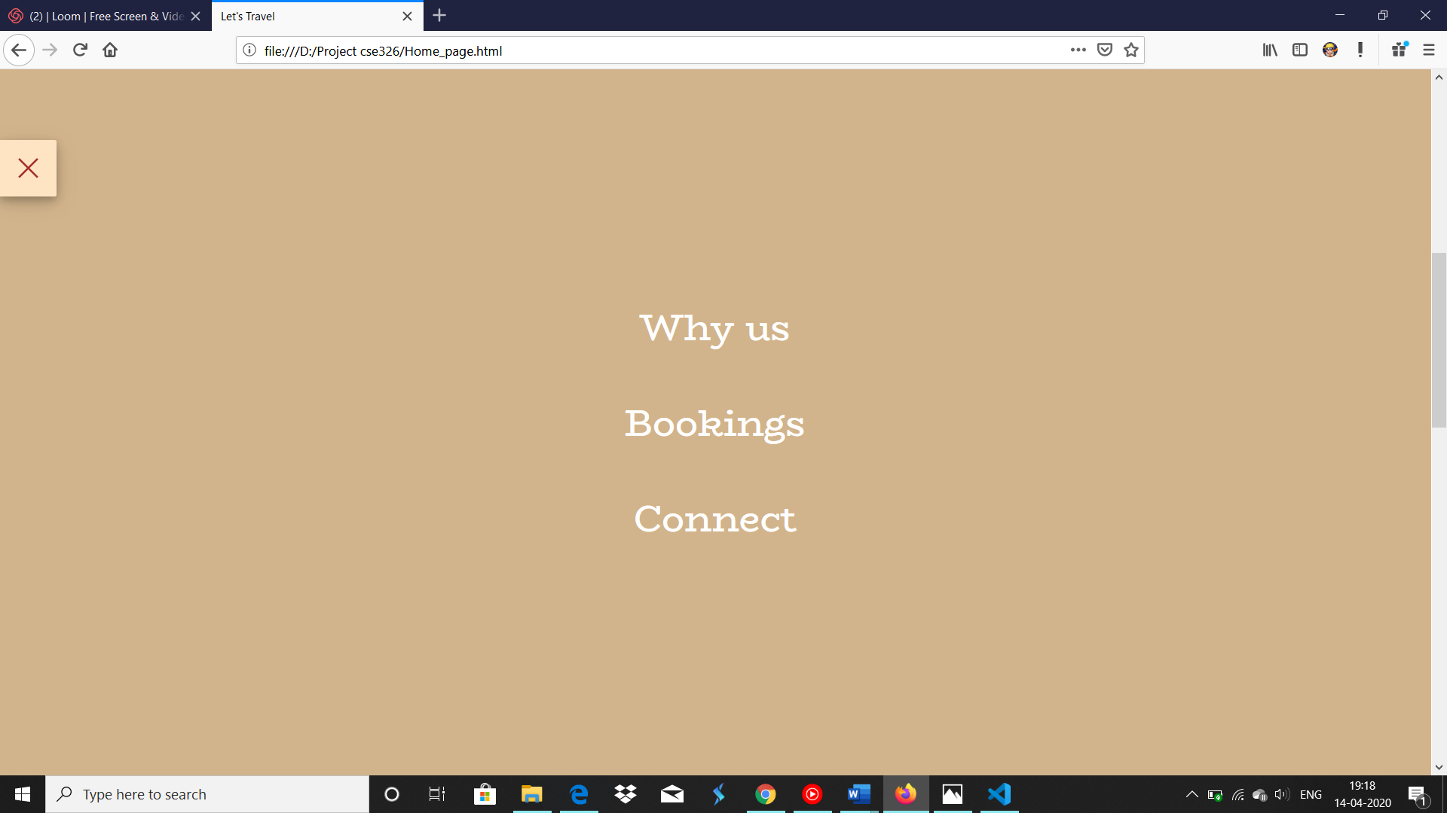

In this page,

If you want to go to home page click on the left top corner button

When you click on “why us” it will redirect to why us id in new tab similarly “Bookings”.

But when you click the “Connect” it will redirect to sign in and sign up page.

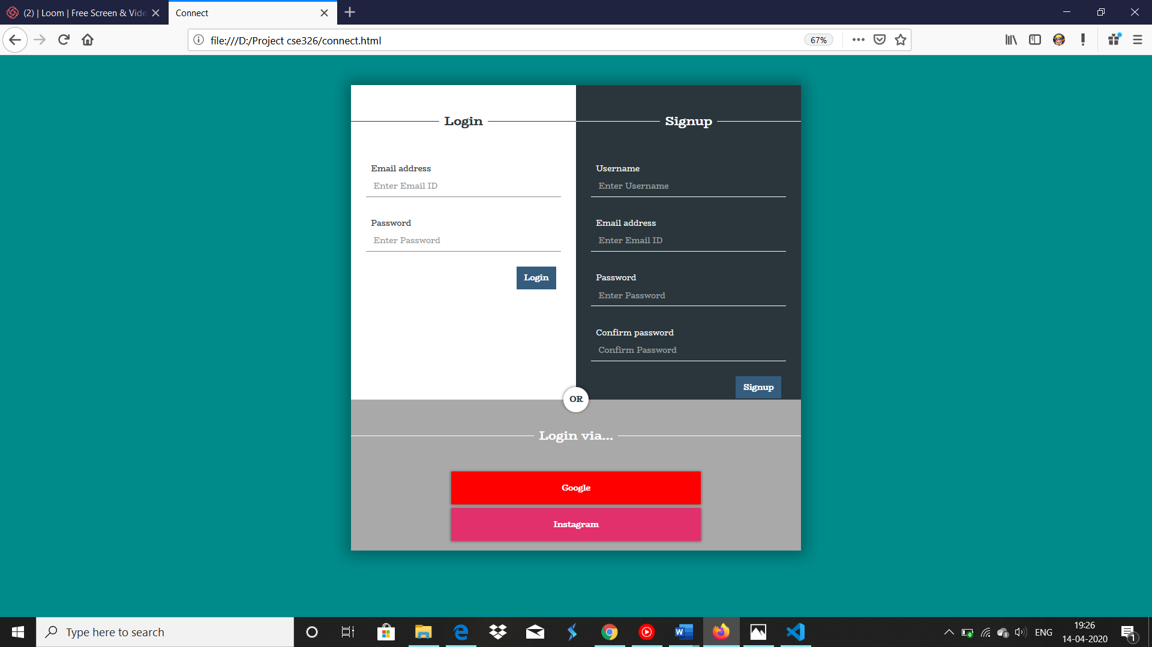

After this we created the payment page it will open when you click the “Book” button.

After this we created the payment page it will open when you click the “Book” button.

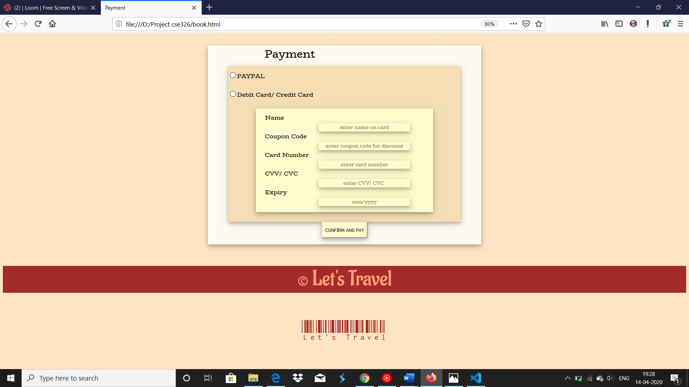

This is our project “Let’s Travel”!!!

Try click on “Search” and “Confirm and Pay” buttons in the page you will get a different page which is out of syllabus!!

**Darshan**

**Reg. No: 11912717**

**Roll No.: K19RDA22**

* **Coding**

**Home Page**

**Organizing every content in the page.**

**Applying CSS to the pages created by other group members.**

**Ticket booking**

* **Designing website**
* **Final report and video recording.**

**Balasubramanian S Nair**

**Reg. No: 11912436**

**Roll No.: K19RDA23**

* **Coding**

**Reviews, Offers**

* **Taking Printouts**

**Allam Chandra Sekhar Reddy**

**Reg. No: 11910876**

**Roll No.: K19RDA24**

* **Coding**

**Creating related links**

**Like sign in and sign up.**

**payment**

* **Collecting information related to websites.**

Technologies;

* HTML
* CSS
* JAVASCRIPT

References:

* MDN Documentations
* W3 school
* YouTube
* Google

Without internet we can’t able to end up with this website.